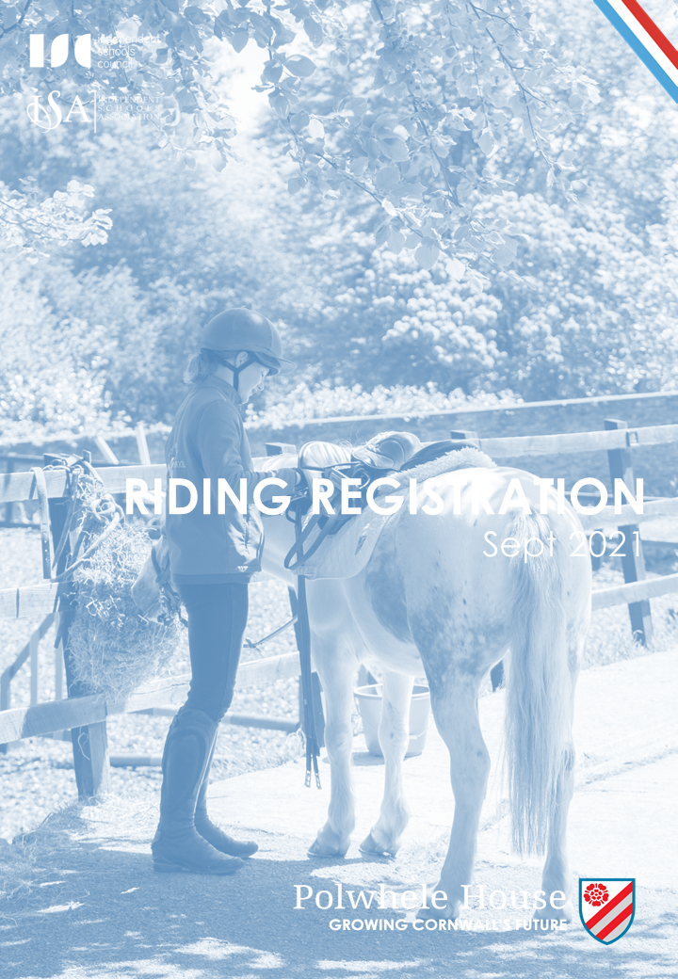

RIDING REGISTRATION FORM

CHILD DETAILS:
NAME:

DATE OF BIRTH: |  |  | AGE:
WEIGHT: |  |  | HEIGHT:
ADDRESS:

POSTCODE:

PARENT EMAIL:

TEL HOME: |  |  | TEL MOB:
HAS THE CHILD YOU ARE SIGNING FOR EVER SUFFERED AN INJURY OR DISCOMFORT WHILE RIDING OR BEEN ADVISED NOT TO RIDE |  | Yes |  |  | No
IF YES, PLEASE DESCRIBE:

PLEASE DETAIL ANY DISABILITY OR MEDICAL CONDITIONS THAT MAY AFFECT YOUR CHILD’S ABILITY TO RIDE. THIS MAY INCLUDE BUT NOT BE LIMITED TO ANY BACK PROBLES AND ANY CONDITIONS, INCLUDING ASTHMA

EMERGENCY CONTACT NAME:

EMERGENCY CONTACT RELATIONSHIP TO RIDER:

EMERGENCY CONTACT NUMBER (IF DIFFERENT FROM ABOVE)

PARENT/GUARDIAN NAME (PLEASE PRINT)

PARENT/GUARDIAN SIGNATURE

DATE

RIDING ASSESSMENT FORM
TO BE COMPLETED BY THE HEAD OF RIDING

This pupil has been assessed and the judgement of his/her capabilities is as follows:

1. | COMPLETE BEGINNER (Lead, rein/lunge)
2. | BEGINNER (beginning walk and trot independently)
3. | NOVICE (walk, trot, canter independently)
4. | INTERMEDIATE (jumping, stage 1)
5. | ADVANCED (stage 2 equivalent and above)

RIDER’S NAME:

DATE & TIME OF LESSON:

LESSON TYPE:

ASSESSMENT LESSON CONTENT: |  | walk / trot / canter / jump
SIGNED (HEAD OF RIDING):

CODE OF CONDUCT
FOR RIDING AT POLWHELE HOUSE

- I understand that riding at any standard has inherent risk and that all horses may react unpredictably on occasions.

- I may fall off and could be injured. I accept that risk.

- I understand that instructions are given for my safety and agree to follow instructions given to me by staff and instructor at the stables.

- I understand that wearing an appropriate riding hat and body protector may reduce the severity of an injury should an accident happen and agree that I will always wear a riding hat whist riding at the riding school. Body protectors must be used for jumping lessons.

- I understand that at all times whilst at the stables my behaviour must be of an excellent standard, and failure to do so may lead to exclusion from riding.

PUPIL NAME
(Please print)
PUPIL SIGNATURE
PARENT/GUARDIAN NAME
(Please print)
PARENT/GUARDIAN SIGNATURE
DATE

PHOTO CONSENT FORM
FOR RIDING AT POLWHELE HOUSE

PUPIL NAME
(Please print)

The riding school regularly takes photographs of children for promotional purposes. We would like to use a photograph of your child for our publications, website or social media accounts.

To comply with the Data Protection Act 1998, we need your permission before we use any
photographs we have taken. Please complete the declaration below and return it to us. Photographs that include children other than your own should be for private use only and not posted on social media sites.

CONDITIONS OF USE
- We will only include a child’s Christian/first name in photo captions for press releases and social media posts, unless we have permission from parents to use full names.
- Addresses will not be disclosed in detail, i.e. a press release may say ‘George from Truro’.
- Personal email addresses and telephone numbers will not be disclosed.

I have read and understood the conditions of use and give permission for my child’s photograph to be used by the riding school for general use.

PARENT/GUARDIAN NAME (Please print)
PARENT/GUARDIAN SIGNATURE
ADDRESS
DATE
Please note that websites can be seen throughout the world and not just in the United Kingdom where UK law applies.

Please tick this box if you would not be happy to receive weekly equestrian news via the Polwhele Post.

